**Ideation Phase**

**Brainstorm & Idea Prioritization**

|  |  |
| --- | --- |
| Date | 16 June 2025 |
| Team ID | LTVIP2025TMID53112 |
| Project Name | OrderOnTheGo |
| Maximum Marks | 4 Marks |

**Brainstorm & Idea Prioritization Template:**

As we brainstormed ideas for *OrderOnTheGo*, our team actively participated in sharing thoughts and suggestions. We took turns explaining each idea, while naturally grouping similar concepts together. This helped us identify common themes and structure our project better.

Once all ideas were shared, we organized the sticky notes into clusters based on their functional relevance. Each group was given a **clear, descriptive label** to reflect its core theme—like *User Flow*, *Restaurant Management*, or *Admin Features*.

This approach gave us a clear overview of our app’s core modules and made it easier to move into prioritization and planning.

Link: https://drive.google.com/file/d/1joWzQ1rh--Oos43iDQ6M8eWeo6-x0Vc-/view?usp=sharing

Reference: <https://www.mural.co/templates/brainstorm-and-idea-prioritization>

**Step-1: Team Gathering, Collaboration and Select the Problem Statement**

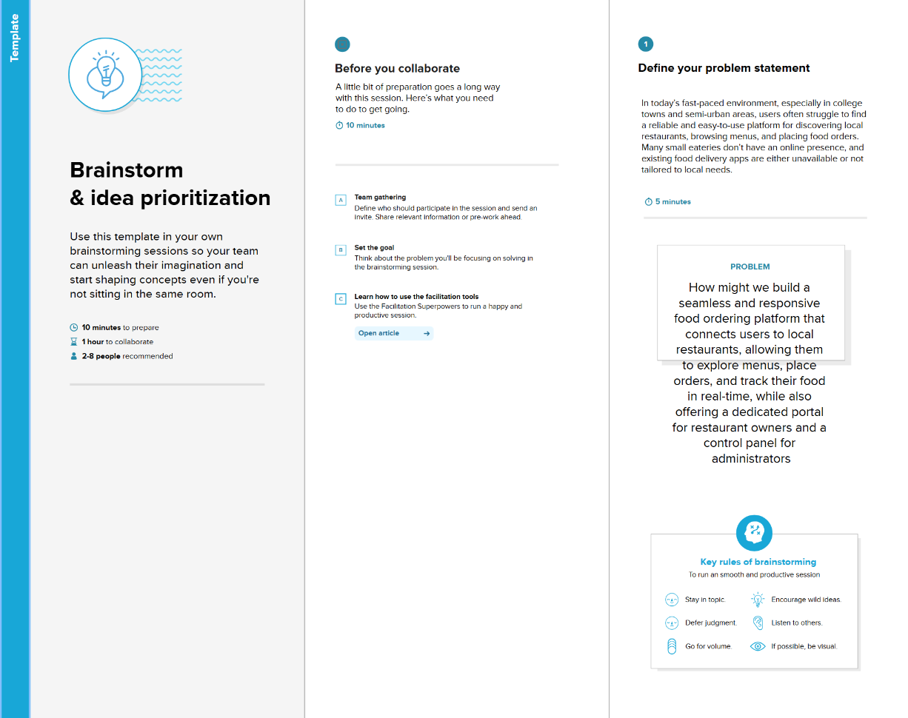

**Step-2: Brainstorm, Idea Listing and Grouping**

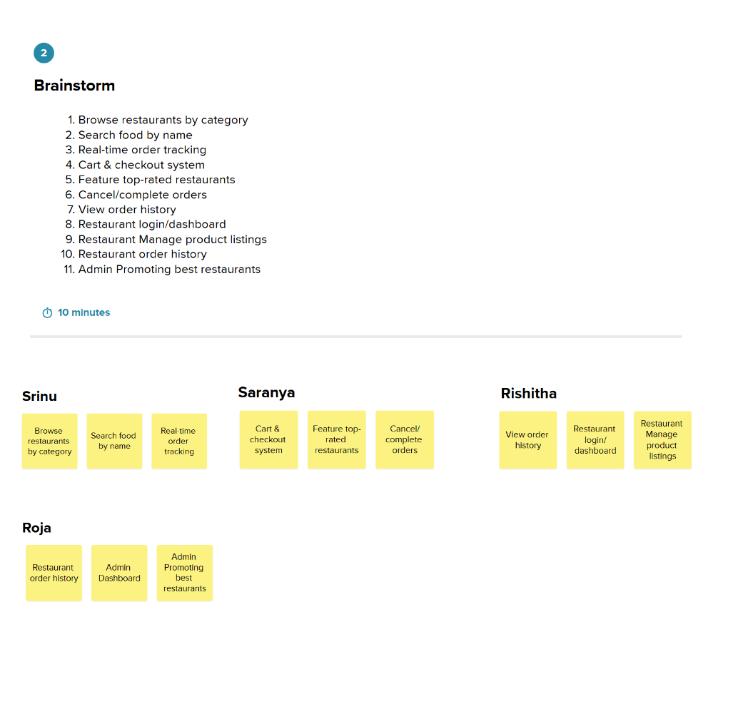

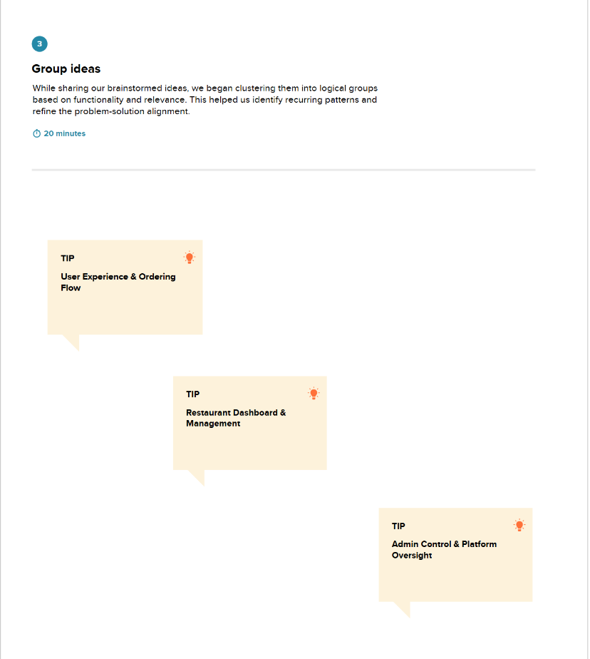

**Step-3: Idea Prioritization**

